**Excel Assignment – 12**

**Dataset:**

**https://docs.google.com/spreadsheets/d/1-Zo-**

**A4gnlLOQxpU8qgpkTJPJCS8cQBmNzKVirJ_Ow0w/edit?usp=sharing**

**Use the above dataset and answer the following questions. Assume that a gang is trying to loot Diamonds and Soft drinks being exported from India.**

1. **How much Diamonds were looted from Chennai Port Trust?**

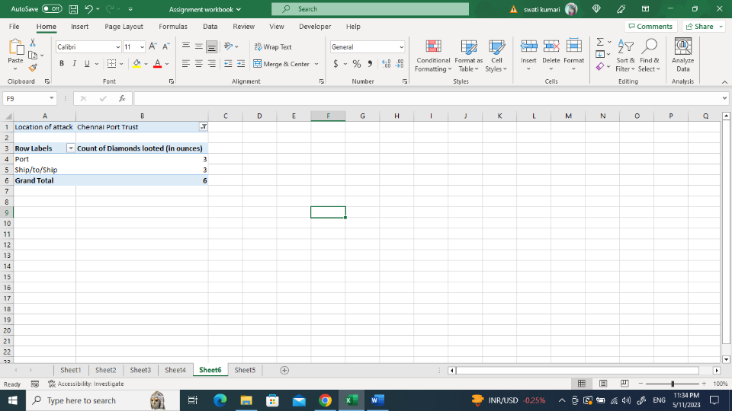

1. **How many Ships were looted near Paradip Port Trust and Chennai Port Trust?**

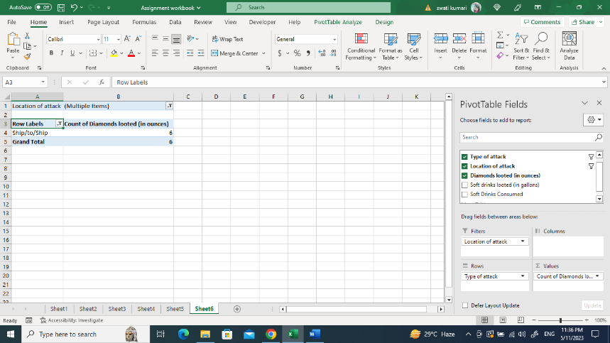

1. **What is the sum total of Diamonds looted from the V.O. Chidambar Nar port trust?**

1. **What is the average amount of Diamonds and Soft drinks looted?**

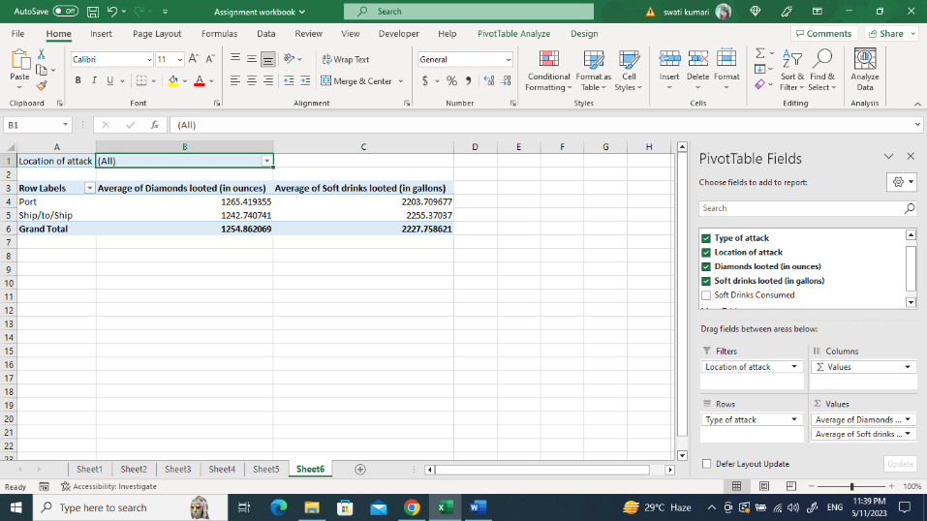

1. **What is the ratio of soft drinks drunk to soft drinks looted?**

